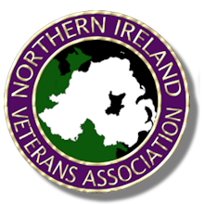
Patron: General Sir Robert Pascoe KCB MBE

Northern Ireland
Veterans' Association
Service of Remembrance

National Memorial Arboretum
11.30 am Saturday10th September 2022

This year’s service will be held at 11.30am on Saturday 10th September 2022 at the National Memorial Arboretum, Alrewas, Staffordshire.
The service will commemorate and remember all those who lost their lives in service of the Crown as a result of the conflict in N. Ireland.
The service will be followed by a parade down to the Ulster Ash Grove for the laying of wreaths.
Following the laying of the wreaths, there will be a 20 minute pause before the parade forms up for the return march to the visitor centre during which the guest of honour will take the salute.
The service is open to all, and all Associations are welcome to parade their standards. It would be appreciated if Associations arranging for groups of their members to attend could notify us of numbers and confirm if their standard will be parading.
We look forward to welcoming you to our annual memorial service.
For further information please email me direct on msangster4@blueyonder.co.uk or visit our website at:

www.nivets.org.uk

