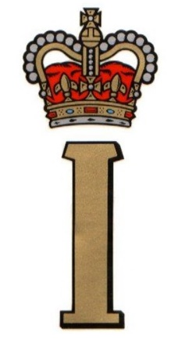 | TEAM RS 373 UPDATE | 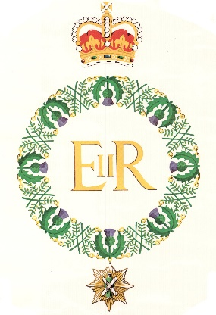

Now that we have been able to meet up again, whilst socially distancing, the opportunity has been taken to work with our film maker, Paul Diffley, to enhance the Scottish Soldiers Post World War 2 Regimental Memories film to include memories from both Gulf War 1 and Bosnia, as well as overall enhancements by including more as yet unseen photographs. The current film is on the Regimental website www.theroyalscots.co.uk and on You Tube: Scottish Soldiers Post WW2 Regimental Memories.
Once again travel restrictions prevented the commemoration in France of The Royal Scots heroic actions at Le Paradis in May 1940, which played a key part in enabling the evacuation of Allied Forces from Dunkirk. 141 members of the 1st Battalion The Royal Scots were killed in Belgium and France in the operations leading up to Dunkirk, some 350 were wounded or posted missing, and 292 became Prisoners of War. Plans are already being prepared for a large party of Royal Scots to take part in the May 2022 event in France. Further details of the actions at Le Paradis are available on the Regimental Website: link https://www.theroyalscots.co.uk/le-paradis/
In July HRH The Princess Royal unveiled the Memorial in Norwich Cathedral to all those serving Royal Norfolk’s, and Royal Scots personnel who lost their lives at Le Paradis. The Regiment contributed to the costs of the memorial however because of travel restrictions a Royal Scots representative was unable to attend.
VJ DAY is on the 15th of August. 146 Royal Scots made the supreme sacrifice in the Burma operations, and a further 477 were wounded or posted missing. Further details are on the Regimental Website; link https://www.theroyalscots.co.uk/the-kohima-campaign-1944/
In less than two months’ time, on Sunday the 3rd of October, two events are taking place at the National Arboretum. The first is the unveiling of a Memorial Stone to commemorate all those who served in The Royal Scots during our 373 years of continuous service to Sovereign and Country..
On the same morning The Lisbon Maru Memorial for all those killed when the armed Japanese merchant ship, MV Lisbon Maru, which was carrying Japanese soldiers and 1816 British Prisoners of War, was sunk by an American submarine on 1st October 1942 will also be unveiled. 181 Royal Scots perished as a result of this action, and many more remained as Prisoners of War for the remainder of World War 2. Further details are available on the Regimental Website: link https://www.theroyalscots.co.uk/lisbon-maru/
In conjunction with the University of St Andrews the virtual Between the Wars and Post 1945 Roll of Honour has been developed and finalized. The Roll records the names of the 44 Royal Scots killed after WW1 in Ireland and Palestine and from 1945 onwards in Palestine then through many campaigns until 2006 when the Royal Regiment of Scotland was formed. In addition, the Roll includes the names of 3 former Royal Scots who were killed whilst serving with The Royal Regiment of Scotland in Afghanistan. The Roll of Honour is available on the Regimental Website: link https://www.theroyalscots.co.uk/ww1-and-ww2-roll-of-honour/
For those interested in the early days of the 1st Battalion’s OP BANNER deployments a visit to You Tube: Op Banner Photographs by ‘Benny’ (Scoop) McArdle https://youtu.be/3BnbHxZqU7k , is recommended. Perhaps you could put a name to the faces of the Royal Scots and personnel attached to the Battalion when on operations in Northern Ireland?
August 2021

