1RS OP BANNER 50th ANNIVERSARY REUNION
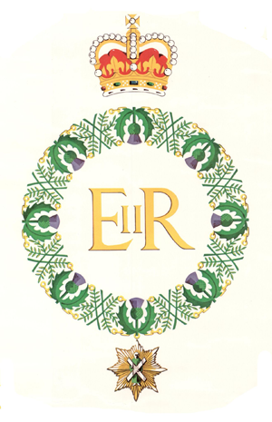
29th FEBRUARY 2020 AT THE ROYAL SCOTS CLUB
BID FOR TICKETS and Admin Instructions

Ser | Information | Response (complete and return)
A | Event serial number (for office use only)
B | Surname
C | Forename/Known as
D | Years in Regiment
E | Final Rank Held
F | Company(s) – Platoon(s)
G | Op BANNER Tours by number *see below
H | RS Association Member Yes/No
I | Association Branch if Member
J | Special Dietary requirements

Op BANNER Tour Dates (list all tours you did by number at G above)
1 | Mar-Jul 1970 | Belfast | 8 | Dec 1987-Mar 1988 | Belfast
2 | May-Jul 1971 | Londonderry | 9 | Sep 1992-Mar 1993 | South Armagh
3 | Oct-Dec 1971 | Belfast | 10 | Nov 1995-Apr 1996 | South Armagh
4 | Jun-Aug 1972 | Belfast/Londonderry | 11 | Jun-Dec 1997 | Fermanagh (part Bn)
5 | Dec 1975-Apr 1976 | South Armagh | 12 | Mar-Aug 1999 | South Armagh
6 | Feb-May 1980 | Belfast | 13 | Aug 2000-Apr 2002 | Ballykelly (Resident)
7 | Mar 1981-Mar 1983 | Ballykinler (Resident)

Notes:

- Eligibility: Holders of the GSM ’62 with clasp Northern Ireland and served with 1RS including attached personnel. Due to spaces available in the Club there are only 140 tickets available.
- Tickets must be pre-booked using this form and are £10 per person, which may be paid on the night at Event Registration: but no money = strictly no entry. Tickets will be issued on the night at Event Registration.
- Priority applications up to 31 January will go to Association Members, thereafter in order of receipt of request. It is expected that there will be no spare seats on the night so please don’t turn up ‘on spec’.
- One copy of the new Booklet covering the 1st Battalion’s Op Banner Tours will be given at Event Registration on the evening of the Dinner. Further copies will be available at a cost of £5 each (plus p&p) from the Regimental Office after the event.
- The Registration Desk will be manned by 1800- start of Dinner. Late arrivals, please ask for Andy Kay.
- Timings: Dinner will be served at 1900 hrs. There will be a cash bar available in The Thirsty First Bar, this bar will close at 2300 hrs.
- Dress: Lounge suit/Blazer and tie (Regimental preferred). No medals.

Applications to be returned to the Regimental Office, The Royal Scots Club, 29-31 Abercromby Place, Edinburgh EH3 6QE or admin@theroyalscots.co.uk.

PLEASE RETURN YOUR APPLICATION NO LATER THAN THURSDAY 13th FEBRUARY 2020.

