Press Release

Scottish World War 2 Defence of Dunkirk Veteran 100th Birthday
Thursday 7th May 2020 at 12:00

George Simpson, a Royal Scots veteran, based in Midlothian, who fought at Le Paradis and spent time in a POW camp in Poland, celebrates his 100th birthday on Thursday 07 May 2020. He is unable to enjoy a family celebration because of the country’s ongoing battle to defeat the invisible enemy, COVID-19.

With VE Day 75th commemoration on Friday 08 May 2020 in mind:
George Simpson was wounded and subsequently captured during the action at Le Paradis 40 miles south of the Channel in May 1940, when The Royal Scots as part of 4 Brigade had a pivotal role to delay the enemy advance to allow the evacuation from Dunkirk to happen. Their orders were to fight to the last man. Following his capture, George spent time in a as a prisoner of war in Poland.
- George joined The Royal Scots as a Territorial in 1937
- Trained at Lanark before moving to the south of England
- Sailed to France in September 1939 with 1st Battalion The Royal Scots as part of the British Expeditionary Force
- George’s favourite pipe tune is the Black Bear
- George worked for 40 years in Duncan’s chocolate factory, Powderhall, Edinburgh and subsequently for Rowntree’s when Duncan’s were bought out
- He has 3 Boys, 5 Girls, 15 Grandchildren and 27 Great Grandchildren with no 28 on the way
Colonel Martin Gibson said:
“George is a marvellous man who is very proud of his family. He is very matter of fact about his time, 80 years ago, fighting for King and Country; when discussing with him his time as a Royal Scot he said: “I had to do it to ensure that Britain’s freedom was preserved”. The Royal Scots Regimental Family wish him Many Happy Returns of the Day; a piper from our Regimental Association Pipe Band will play for him outside his house.”

Contacts:

Colonel Martin Gibson 07798 877073 Press Office 07768 812620

Explanatory Notes:

Website addresses:
- Home Page: http://www.theroyalscots.co.uk/
- BEF Deployment 1939: http://www.theroyalscots.co.uk/2nd-world-war-ww2/
- Le Paradis defence: http://www.theroyalscots.co.uk/le-paradis/

In 2006, The Royal Regiment of Scotland was formed from its predecessor Scottish Infantry Regiments; after 373 years of unbroken service The Royal Scots left the British Army’s order of battle.

Details of the Regiment’s history are available on our web site. http://www.theroyalscots.co.uk/

Photos:

POW 1940’S 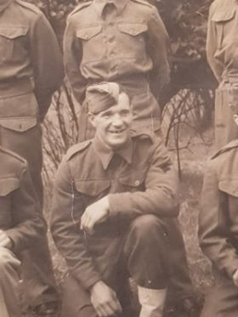
Today

