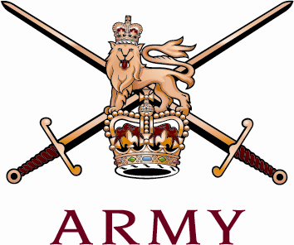 | REGIMENTAL HEADQUARTERS  THE ROYAL REGIMENT OF SCOTLAND  THE CASTLE  EDINBURGH  EH1 2YT  Telephone: 0131 310 5155 Military: 94740 5155  Fax: 0131 310 5075  Email: andrew.kirk663@mod.gov.uk |  |  | 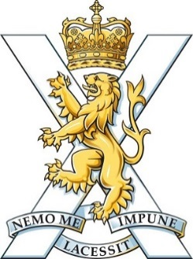
To all Regimental Officers |  | RHQ SCOTS/1012-3  7th January 2019

THE ROYAL REGIMENT OF SCOTLAND OFFICERS’ REGIMENTAL DINNER 2019

- The 2019 Regimental Dinner will take place in The Royal Scots Club, Abercromby Place, Edinburgh on Friday 5th April 2019.

2. The dinner is open to all Regular, Reserve and Cadet Officers, serving and retired in the Regiment or its antecedents. All battalions are requested to disseminate this letter to their officers. RHQ SCOTS will disseminate to all others. All officers are asked to pass this information on as widely as possible.

3. Outline timings are 7.30 for 8.00pm.

4. Dress will be black tie or highland dress with miniatures. Mess dress is not required.

5. Those wishing to attend the dinner should reply to the Regimental Adjutant by Friday 15th March 2019.

6. The cost to an individual will be £60. This will include pre-dinner drinks as well as wine and port on the table. A cash bar will be available throughout for the purchase of other drinks. Payments can be made by:

- Cheque. Cheques should be made out to “The Royal Regiment of Scotland Regimental Trust” and posted to the Regimental Adjutant.

- BACs transfer (preferred method). Details for transfer of money electronically are:

- Account Name: Royal Regiment of Scotland Regimental Trust.

- Sort Code: 80-11-30.

- Account Number: 06010477.

- Payment reference: “Initials Surname Dinner 19”.

7. To ensure subsequent dissemination of information concerning the dinner and to capture dietary requirements officers are asked to complete the proforma at Annex A and return it no later than 15 Mar 19.

8. The Regimental Dinner is an occasion where officers who are disparate by very nature of the battalions’ locations, staff appointments and postings can come together to enjoy a good meal in excellent company in a unique location. Attendance is encouraged.

{Original Signed}

A S Kirk
Capt
Regimental Adjutant

ANNEX A TO
G1/021
DATED 07 JAN 19

ATTENDANCE PROFORMA – THE ROYAL REGIMENT OF SCOTLAND OFFICERS’ DINNER

1. I wish / do not wish to attend the Royal Regiment of Scotland Officers’ Dinner.

2. Please advise of any special requirements, e.g. accessibility or dietary needs:

3. For all, whether attending the dinner or not, please fill out the following personal details and return in order that RHQ’s database can be kept up to date.

Rank, initials and name:

Address:

Post Code:

Telephone:

Mobile:

e-mail (civilian e-mail preferred):

Please return this proforma by 15 Mar 2019 either by:

E-mail (preferred method) to: andrew.kirk663@mod.gov.uk or post to:

Regtl Adjt
RHQ SCOTS
The Castle
Edinburgh
EH1 2YT

Payment will not be accepted on the evening at the door.
Failure to include your name and initials as the payment reference may lead to the payment being rejected and the consequent denial of a ticket.

